Notebook 6: ExpressJS POST Request

|  |
| --- |
| app.post('/feedback', (req, res) => {}; |

In this line of code, you use post to create a post endpoint in expressjs.

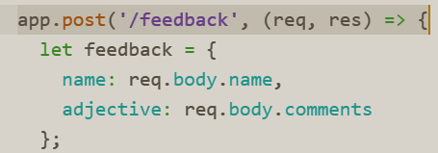

|  |
| --- |
| name: req.body.name, |

This line of code allows post to be able to read the requests body.

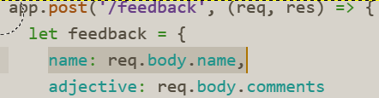

|  |
| --- |
| var urlencodedParser = bodyParser.urlencoded({ extended: false }) |

This line of code tells ExpressJS to use its bodyparser module to parse URL encoded request bodies.

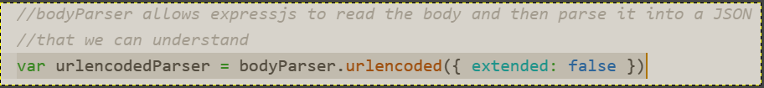

|  |
| --- |
| var stuffs = 'Your name has been received.'  res.end(JSON.stringify(stuffs); |

This line of code converts POST data into JSON files/data.

